

Dr. Angela, Mills inc.
2023-11-10
Dr. Mills
34172 Stephanie Freeway Suite 575, Lopezfort, MA 49237
Phone: 7470981467
Fax: 3716669195

Re: Sharon, Burns
PHN: 2709651377
Birthdate: 11-Sep-1996
Address: 77485 Charles Stream Apt. 196, East Michael, DE 76253
Patient number: 5214949356

To Whom It May Concern:

This is a medical letter to state the above patient is pregnant with expected delivery date of 22-Feb-2025. Hoping this information is satisfactory for your requirements.

Thank you.

Sincerely,
Dr. Angela, Mills
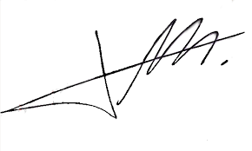
FRCS© NCMP
Clinical Assistant Professor, UBC
Department of Obstetrics and Gynecology SMH

